**Objective**

The primary objective of this lab was to configure RIPv1 on Cisco routers and establish inter-network communication between two LANs. This involved assigning IP addresses, configuring interfaces, and enabling the RIP routing protocol.

**Topology**

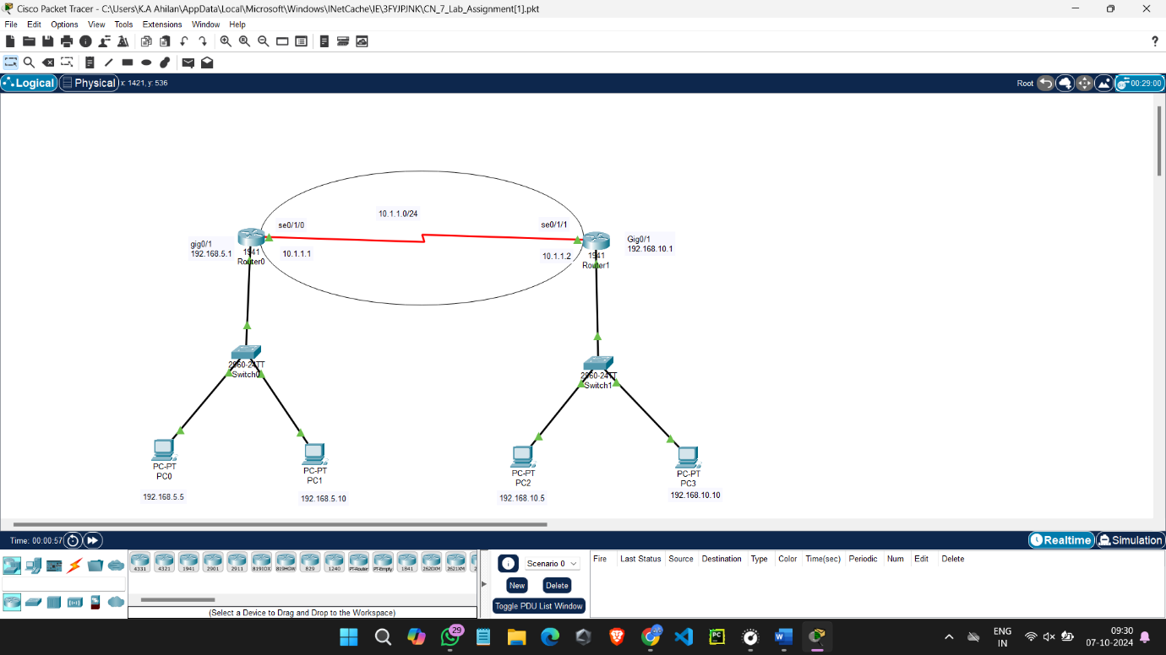

**Procedure**

1. **Network Setup:**
   * Added two routers, two switches, and four PCs to the Packet Tracer workspace.
   * Connected devices using serial and straight-through cables as specified.
2. **Interface Configuration:**
   * Assigned IP addresses to the GigabitEthernet and Serial interfaces on both routers.
   * Enabled the interfaces.
3. **RIP Configuration:**
   * Enabled the RIP routing protocol on both routers.
   * Specified the network addresses for the LANs connected to each router.
   * Optionally adjusted RIP timers (update, invalid, and holddown).
4. **Verification:**
   * Pinged devices on the other LAN from a device on the first LAN to verify connectivity.
   * Used show ip route to verify routing table entries.
   * Used show ip protocols to verify RIP configuration.

**Results**

After completing the configuration, successful communication was established between the two LANs. Ping tests were successful, and the routing tables on both routers showed the correct routes.

**Conclusion**

This lab demonstrated the process of configuring RIPv1 on Cisco routers to enable inter-network routing. The results confirm that RIPv1 is functioning correctly and that devices on both LANs can communicate with each other.

**Additional Notes**

* **RIPv1 Limitations:** While RIPv1 is a simple and easy-to-configure protocol, it has limitations such as a maximum hop count of 15 and its reliance on periodic updates. In larger networks, more advanced protocols like OSPF or EIGRP might be more suitable.
* **RIPv2:** RIPv2 introduced improvements such as authentication and variable-length subnet masks (VLSM). Consider exploring RIPv2 in future labs to understand its advantages.